Quiz system Admin and User dashboard

Admin will create a training(quiz) and assign it to users in admin dashboard.  
  
Quiz system no need time frames for all system now.

1. Admin dashboard

And then admin should see something like this  
  
Pending and Completed 2 tabs (Pending, Completed)  
  
Pending Status Fields:   
Key: value  
Docs: View   
Training title: String,   
Training Details:String,   
Due to Date:created at,   
Completed Date: completed at

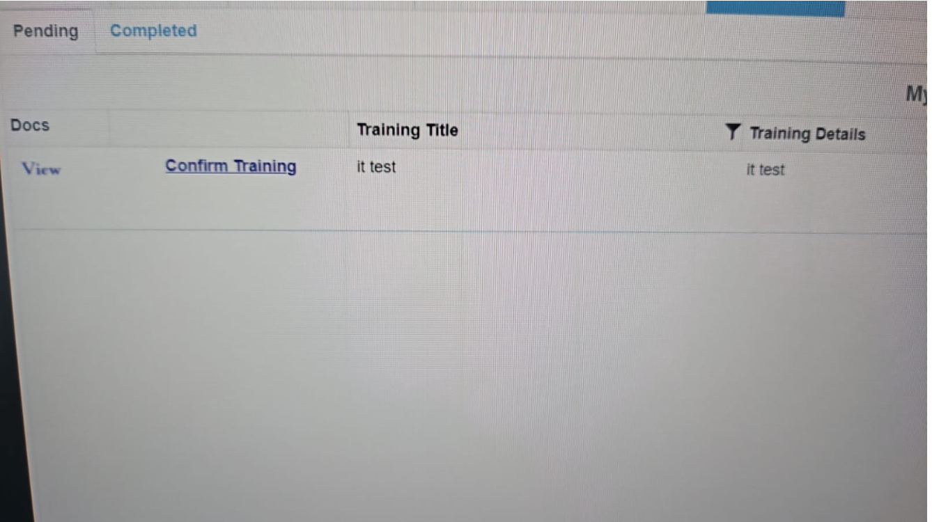

Completed Status fields  
  
Key: value  
Docs: View training, View Certificate,  
 Training title: String,   
Training Details:String,   
Due to Date:created at,   
Completed Date: completed at

Passing users: number

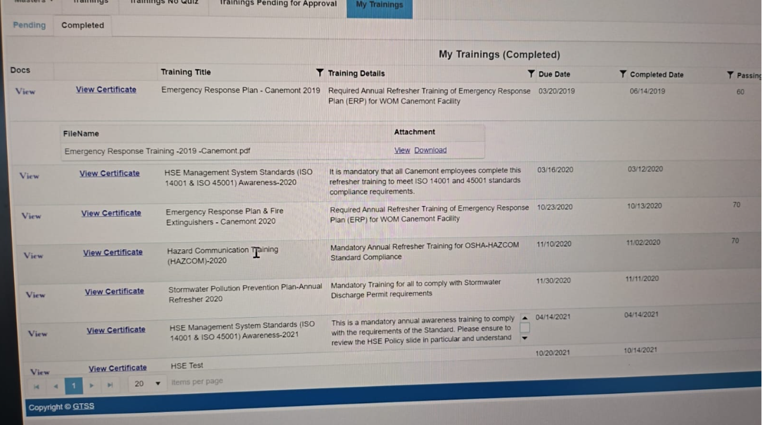

And then once they complete the training

They will get an auto-generated certificate PDF

With User Name, training title and date of completion



2.User dashboard

In user dashboard, users can see quiz lists and choose anything and pass with checkbox answers and next button without time frame.  
This system no need time frame for all training(quiz).

Many questions and I can give answers. If user select wrong answer, he needs to do training again. We can keep minimum passing percentage (85%)

If user gives more wrong answers, , Certificate PDF can not make automatically, no passing, needs to do training again or redirect to quiz list page ,

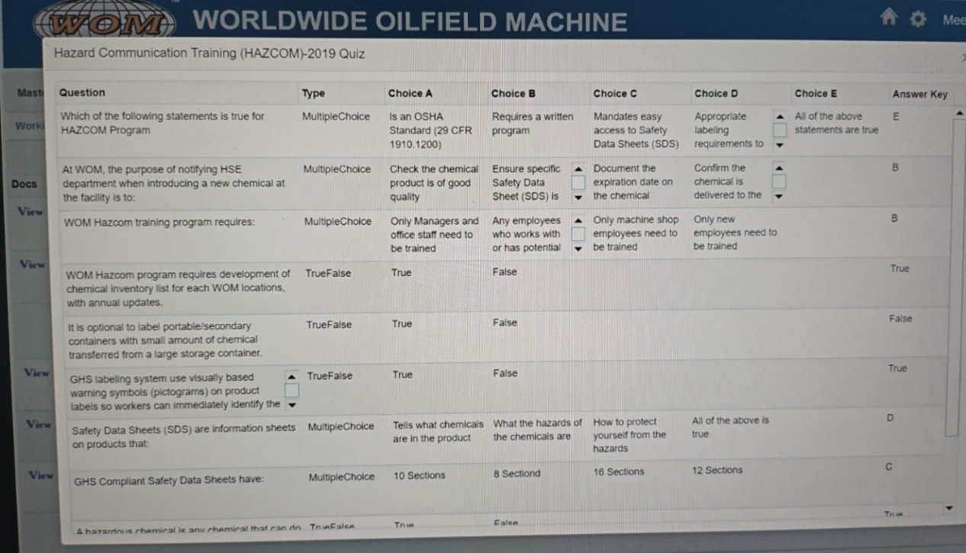

If user scores more than 80% he passes and gets certificate to download

If not, he fails and tries again

Yes, we can create a rough certificate where it automatically fills in name, quiz title and date of completion in blank space